Frontend Assignment

HTML

**Q-1 Are the HTML tags and elements the same thing?**

A: No, both are the different things,

Tags are define in angle brackets <>, usually tags come in pairs like opening tag and closing tag.

Elements are made with mainly three things,

1. Tags
2. Content
3. Optional attributes

Examples: Tags: - <p></p>, <h1></h1>

Elements: - <a href=””>click to visit here</a>

Tag attr content

**Q-2 What are tags and attributes in HTML?**

A: Tags are elements used to mark up or define different parts of a web page's content.

Example :- (p , div , img ,span)

Attributes used for change the behaviour of the element and attributes appear in opening tag.

Example :- (img src=””), (a href=””) where src and href are attributes.

**Q-3 What are void elements in HTML? With Example**

1. Void elements in HTML are elements that do not have a closing tag. They are self-closing tags that do not contain any content. Void elements are used to insert content into a web page but do not require an opening and closing tag pair like other HTML elements.

* **Example:-**

<img>,<br>,<link>,<input>,<meta>

**Q-4 What are HTML Entities? With Example.**

1. HTML entities are special codes used to represent reserved characters, symbols, and special characters in HTML. These entities are used when you want to display characters that have special meanings in HTML, such as <, >, &, ", ', and non-breaking space.

**Example:-**

**&lt;** represents **<**

**&gt;** represents **>**

**&amp;** represents **&**

**&quot;** represents **"**

**&apos;** represents **'**

**&nbsp;** represents a non-breaking space

**Q-5 What are different types of lists in HTML? With Example.**

1. In HTML, there are three main types of lists: Unordered lists (**<ul>**),

Ordered lists (**<ol>**),

Definition lists (**<dl>**).

Examples:-

1. <ul>

<li>1</li>

<li>2</li>

<li>3</li>

</ul>

1. <ol>

<li>red </li>

<li>yellow </li>

<li>green </li>

</ol>

1. <dl>

<dt>HTML</dt>

<dd>HyperText Markup Language</dd>

<dt>CSS</dt>

<dd>Cascading Style Sheets</dd>

</dl>

Q-6 **What is the ‘class’ attribute in HTML? With Example.**

**A:-** The class attribute in HTML is used to specify one or more class names for an HTML element. Classes are used in conjunction with CSS (Cascading Style Sheets) to apply styling and formatting to elements on a webpage. By assigning a class to an element, you can target and style that element using CSS rules.

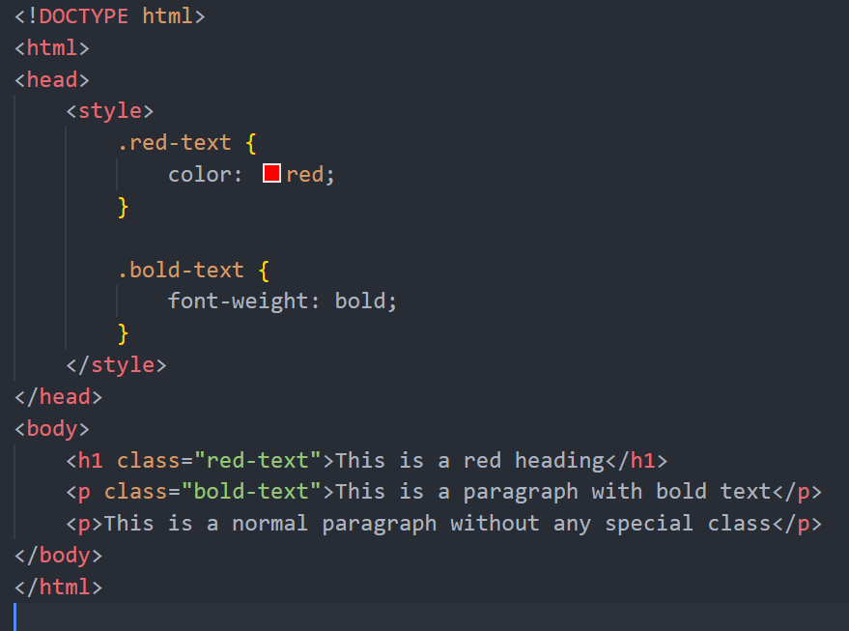

The class attribute is used to assign the class names red-text and bold-text to the <h1> and **<**p**>** elements, respectively.

In the **<**style**>** section, CSS rules are defined for the **.**red**-**text class to set the text color to red and for the **.**bold**-**text class to set the font weight to bold.

As a result, the **<**h1**>** element with the class red**-**text will have red text, and the **<**p**>** element with the class bold**-**text will have bold text.

Q-7 **What is the difference between the ‘id’ attribute and the ‘class’ attribute of HTML elements? With Example**.

A- In summary, the **id** attribute is used to uniquely identify an element, while the **class** attribute is used to apply styles or behaviours to groups of elements with similar characteristics.

**Q-8 What are the various formatting tags in HTML?**

**Top of FormA-** HTML provides several formatting tags that allow you to change the appearance of text and elements on a webpage. Here are some of the common formatting tags in HTML:

**<b> and <strong>**: These tags are used to make text bold. **<b>** is a presentational tag, while **<strong>** is a semantic tag indicating stronger emphasis.

**<i> and <em>**: These tags are used to italicize text. **<i>** is a presentational tag, while **<em>** is a semantic tag indicating emphasis.

**<u>**: This tag is used to underline text. However, it's important to note that underlining text is generally discouraged for regular content as it can be confused with hyperlinks.

**<strike> and <s>**: These tags are used to strike through text, indicating that it has been deleted or is no longer valid.

**<sub> and <sup>**: These tags are used to create subscript and superscript text, respectively. Subscript text appears slightly below the baseline, while superscript text appears slightly above the baseline.

**<mark>**: This tag is used to highlight text with a background color, often used to indicate a specific portion of text that is of particular importance or relevance.

**<small>**: This tag is used to reduce the size of text, typically used for disclaimers, copyright notices, or fine print.

**<abbr>**: This tag is used to define an abbreviation or acronym, providing a full explanation when the user hovers over the abbreviated text.

**<code>**: This tag is used to represent computer code or program code within text. It typically preserves whitespace and uses a monospaced font for better readability.

**<pre>**: This tag is used to display preformatted text, preserving whitespace and line breaks as they appear in the HTML code. It's commonly used for displaying code snippets or ASCII art.

**<blockquote>**: This tag is used to indicate a block of text that is a quotation from another source, often styled with indentation or other formatting.

**<cite>**: This tag is used to indicate the title of a work, such as a book, article, or movie, typically used within a **<blockquote>** or **<cite>** tag.

**Q-9 How is Cell Padding different from Cell Spacing? With Example.**

Cell padding and cell spacing are attributes used in HTML tables to control the spacing and padding around the content within table cells. Here's how they differ:

1. **Cell Padding**:
   1. Cell padding refers to the space between the content of a cell and the cell's border.
   2. Cell padding adds space inside the cell, affecting the distance between the content and the cell's border.

Example:-

<table cellpadding="10">

<tr>

<td>Cell 1</td>

<td>Cell 2</td>

</tr>

<tr>

<td>Cell 3</td>

<td>Cell 4</td>

</tr>

</table>

**B-Cell Spacing**:

* 1. Cell spacing refers to the space between adjacent cells in a table.
  2. Cell spacing adds space between cells, affecting the distance between the borders of adjacent cells.

Example:-

<table cellspacing="5">

<tr>

<td>Cell 1</td>

<td>Cell 2</td>

</tr>

<tr>

<td>Cell 3</td>

<td>Cell 4</td>

</tr>

</table>

Q-10 How can we club two or more rows or columns into a single row or column in an HTML table? With Example.

1. If we want to clubrows then we have tag called rowspan and same as columns we have tag called colspan in HTML.
2. Examples:-
   1. <table>
   2. <tr>
   3. <td Colspan =”5” rowspan =”6” </td>
   4. </tr>
   5. </table>

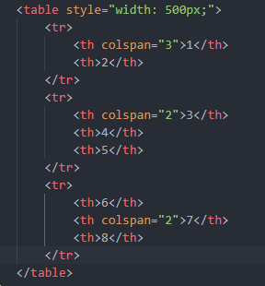

Q-11 What is the difference between a block-level element and an inline element?

1. Block level element take the 100% width of there perent element and in the inline element take width of there content only.
2. Examples:
   1. P and div are block elements
   2. Span , a , abbr , br are inline elements

Q-12 How to create a Hyperlink in HTML? With Example.

1. In the html there is tag called

<a href=””></a>

This is how we can add hyperlink in html

Example:

<a href=”www.google.com”>Click to open Google</a>



Q-13 What is the use of an iframe tag? With Example.

1. Iframe tag use for load another html page in same document, mostly iframe used for embedded videos,adv,etc.
2. Example:



**Q-14** What is the use of a span tag? Explain with example?

1. The <span> tag is an inline container used to mark up a part of a text, or a part of a document.
2. Span mainly use for SEO help beacause its html5 tag
3. Example:
   1. <span>content</span>

Q-15How to insert a picture into a background image of a web page? With Example.

1. Within the starting <body> tag in your Html file type<Body background=””> give the path of the image we want to add.
2. Example:
   1. <Body background=”./image.png”>

Q-16 How are active links different from normal links?

1. Normal link colour is purple and active link colour is blue.
2. active links are typically link to lead the web site.
3. normal links are are broken.

Q-17 What are the different tags to separate sections of text?

1. There are some tags to break the line and start the content from new line
2. Examples:
   1. <br>
   2. <hr>

Q-18 What is difference between HTML and XHTML?

1. HTML's primary purpose is to display content, given in a text-based document, in a graphical form in the browser.

Q-19 What is SVG?

1. SVG define as Scalable Vector Graphics, which uses for the web.
2. In SVG files each element and attributes can be animated.

Q-20 What are logical and physical tags in HTML?

1. Physical tags maily use for give some visual appearance to the content
2. Logical tags used for add some logical value to the content

Q-21 Create below example using only HTML tags without CSS.

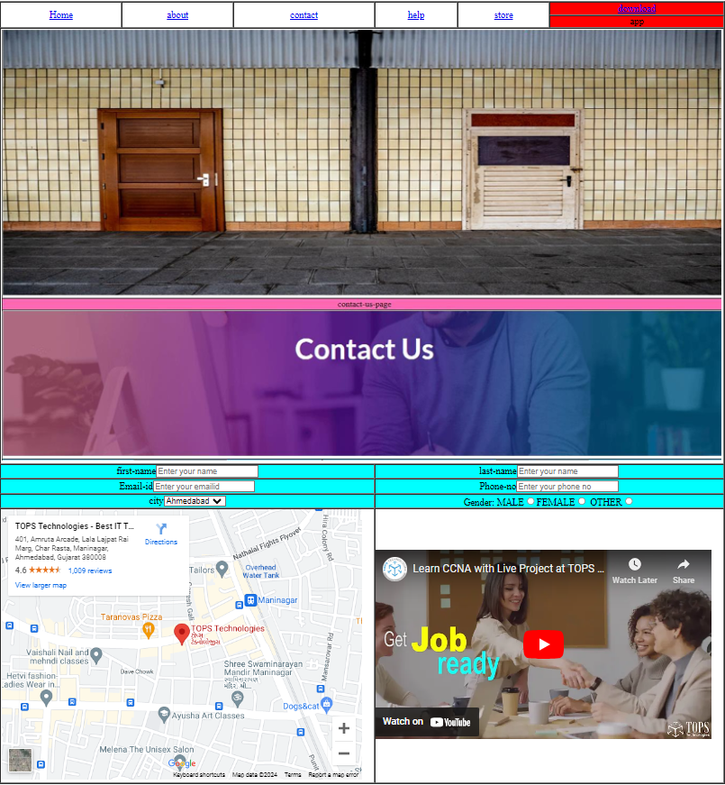

Code for this picture is given below

<!DOCTYPE html>

<html lang="en">

<head>

    <meta charset="UTF-8">

    <meta name="viewport" content="width=device-width, initial-scale=1.0">

    <title>HomePage</title>

</head>

<body>

    <table border="1" cellspacing="0">

        <nav>

            <tr>

                <td rowspan="2" align="center"><a href="#">Home</a></td>

                <td rowspan="2" align="center"><a href="#">about</a></td>

                <td rowspan="2" align="center"><a href="#">contact</a></td>

                <td rowspan="2" align="center"><a href="#">help</a></td>

                <td rowspan="2" align="center"><a href="#">store</a></td>

                <td align="center" bgcolor="red"><a href="#">download</a></td>

            </tr>

            <tr>

                <td align="center" bgcolor="red">app</td>

            </tr>

        </nav>

        <tr>

            <td colspan="6">

                <img src="ass temp img.PNG" alt="img" width="1200px">

            </td>

        </tr>

        <tr align="center" bgcolor="aqua">

            <td colspan="3"><label for="firstname">first-name</label><input type="text" name="firstname" id="firstname"

                    placeholder="Enter your name"></td>

            <td colspan="3"><label for="lastname">last-name</label><input type="text" name="lastname" id="lastname"

                    placeholder="Enter your name"></td>

        </tr>

        <tr align="center" bgcolor="aqua">

            <td colspan="3"><label for="emailid">Email-id</label><input type="email" name="emailid" id="emailid"

                    placeholder="Enter your emailid"></td>

            <td colspan="3"><label for="phoneno">Phone-no</label><input type="number" name="phoneno" id="phoneno"

                    placeholder="Enter your phone no"></td>

        </tr>

        <tr align="center" bgcolor="aqua">

            <td colspan="3"><label for="city">city</label><select name="city" id="city">

                <option value="Ahmedabad">Ahmedabad</option>

                <option value="Surat">Surat</option>

                <option value="vadodara">Vadodara</option>

                </select></td>

            <td colspan="3"><label for="gender">Gender: </label><label for="male">MALE</label><input type="radio" name="abc" id="male"><label for="female">FEMALE</label><input type="radio" name="abc" id="female"> <label for="other">OTHER</label><input type="radio" name="abc" id="other"></td>

        </tr>

        <tr>

            <td colspan="3"><iframe src="https://www.google.com/maps/embed?pb=!1m18!1m12!1m3!1d3672.7236044390233!2d72.60635807603587!3d22.997189117273564!2m3!1f0!2f0!3f0!3m2!1i1024!2i768!4f13.1!3m3!1m2!1s0x395e85c2fc005927%3A0x918e69150ca1c935!2sTOPS%20Technologies%20-%20Best%20IT%20Training%20Institute%20in%20Ahmedabad!5e0!3m2!1sen!2sin!4v1712231788517!5m2!1sen!2sin" width="600" height="450" style="border:0;" allowfullscreen="" loading="lazy" referrerpolicy="no-referrer-when-downgrade"></iframe></td>

            <td colspan="3"><iframe width="560" height="315" src="https://www.youtube.com/embed/Y9pgsPW-KIE?si=nizKPRCFMiqkXgWc" title="YouTube video player" frameborder="0" allow="accelerometer; autoplay; clipboard-write; encrypted-media; gyroscope; picture-in-picture; web-share" referrerpolicy="strict-origin-when-cross-origin" allowfullscreen ></iframe>

            </td>

        </tr>

    </table>

</body>

</html>

Thank You for viewing my HTMl assignment ! I hope you enjoyed exploring it as much as I enjoyed creating it.

Feel free to reach out for any questions or feedback.